Technical Architecture Document
AT4AM
Authoring tool for amendments

Approval
Name | Role  MOA/MOE | Date  Approval | Approval  Y/N | Address  DG or Company
Juho ESKELINEN | MOA-Project Owner |  | Y | IPOL
Claudio FABIANI | MOE-Project Manager |  | Y | ITEC
CIRCULATION
Name -Telephone number |  | DG or Company | ERICA code
Roland THORPE | RT | ITEC | E
Olivier LEBOEUF | OL | ITEC | E
Claudio FABIANI | CF | ITEC | R
Juho ESKELINEN | JE | IPOL | A
Veronica BASTIANETTO | VB | IPOL | E
Fernanda MARTINS | FM | IPOL | E
Flemming SORENSEN | FS | ITEC | I
Updates
Version | Date | Sections changed | Description | Author(s)
0.1 | 05/04/2010 |  | Creation | CF
0.2 | 20/04/2010 |  | Complete document | PL, LDJ
1.0 | 28/04/2010 |  | Final review | CF
1.1 | 15/11/2011 | All | Use of new document template, general update and request for new runtimes (section 2.4) | LDJ
1.2 | 25/06/2012 | 2.4 | New HornetQ runtime jms4am | LDJ
Table of content
1. General Introduction 4
1.1. Purpose 4
1.2. Usage conventions 4
1.3. Applicable and Reference Documents 4
1.4. Glossary 5
1.5. Procedure 'Technical Architecture' 5
2. Architecture - Description 6
2.1. Basic information 6
2.2. Network Architecture Schema 6
2.3. Software Architecture 6
2.4. Required Standard Runtimes 8
2.5. Non-standard server-side softwares list 8
2.6. Integration 8
2.7. Security 11
3. Specific Development Tools 12
4. Annex: Statistics on AT4AM usage 13

General Introduction

Purpose
This document contains a description of the AT4AM project for submission to the IT correspondent of the DIT for its opinion on the technological/technical assumptions on which it is based. It is essential for this opinion to be sought in order to ensure that the elements on which the project's success will depend (methods, architectures, tools, components, etc.) are valid and authorised within the EP.

Usage conventions
The parts in yellow indicate the area where information should be entered, and must remain in yellow to highlight information connected with the project.
Where a chapter or section is not considered to be applicable, put ‘NOT APPLICABLE’.
Click on the Show/Hide button in the toolbar to display/hide guidance on filling in this document.
Guidance displayed.

Applicable and Reference Documents
This chapter sets out the reference documents on which this guide is based.

Applicable Documents
This section details the applicable documents used in drafting this document. The applicable documents are standards, specimen plans which need to be applied and whose application is verifiable.
N° | Title | Remarks
[1] | AT4AM3_TE_CHP_EN_v30.doc | Project Charter for AT4AM Phase III
[2]
[3]

Reference Documents
This section details the reference documents used in drafting this document. Reference documents help in defining the project but are not directly applicable (e.g. software reference manuals, sample files from outside firms, meeting papers).
N° | Title | Remarks
[1] | 1.4 ALP-AT4EP-V1.2.doc | Avis de lancement de projet AT4AM
[2] | AT4AM3_TE_DEB-EN_v30.doc | Needs study for AT4AM Phase III
[3] | AT4AM3_TE_SGP_EN_v30-1.0.doc | Scope statement and project management for AT4AM Phase III

Glossary
The glossary is available at ICTASnet : - Zone 'Vos indispensables'-Glossaire.
Abbreviation | Description
DTA | Technical Architecture Document
RHR | Runtime Hosting Request

Procedure 'Technical Architecture'

Sending a Technical Architecture Document (DTA)
The DTA and RHR(s) documents have to be sent to the IT correspondent of the DIT.

Validation of the DTA
As soon as the DTA is completely validated then the DTA is sent to ITO to continue the treatment along with one or multiple Runtime Hosting Requests (RHR).

ICTAS support
During the project, ICTAS can support the team project (MOA+MOE) but on request only.
ICTAS provides relevant information (standard, methods) in the Quality Assurance Manual and the appropriate documents (templates) for the project.

ITO support
ITO deals with the DTA as soon as it is validated by ICTAS.
ITO initiates a meeting with the stakeholders of the project in order to organise the technological environments necessary for the project.
For more information see EICInet.

Architecture - Description

Basic information
This chapter describes the deliverables (applications, components, integration component) of the product in the EP's network using a synthetic schema.
Intranet | Y
DMZ | N
VLAN dedicated | N
Internet access through the EP portal | Y
Other | User access from outside EP using Mobile Office and Terminal Server

Network Architecture Schema
Insert a synthetic schema representing general software components in their respective network zones (application servers, applications, products...etc), as well as their interactions and the protocols used for these interactions.

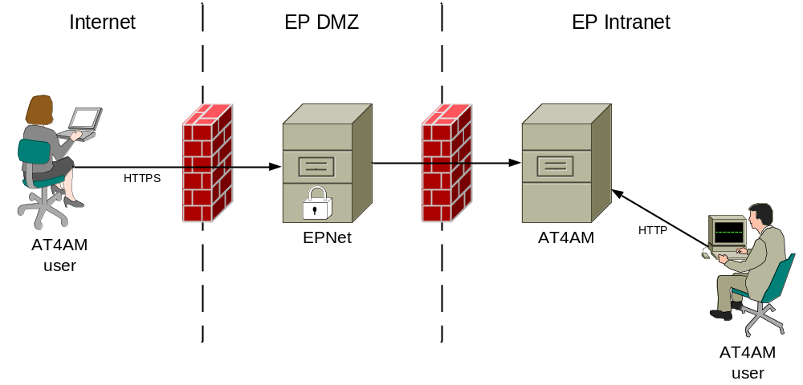

Software Architecture
This chapter describes the software architecture according to the following schema:
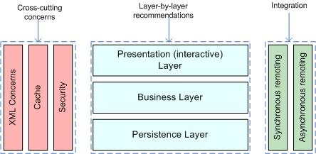
List the technologies/libraries used.
Client User interface | HTML, JavaScript, JQuery, Google Web Toolkit (GWT), TinyMCE
Server Presentation layer | Struts 2, JSP
Server Business layer | Spring
Server Persistence Layer | Hibernate ORM (Object/Relational Mapping)
Synchronous Remoting (WS, RMI...) | SOAP / REST Web Services (Apache CXF implementation)
Asynchronous Remoting (JMS...) | Y
XML Handling | Xalan / Freemarker  SAX/DOM - Xerces
Cache | Spring cache (EHCache implementation)  Hibernate cache (EHCache implementation)
Security | Application container  EP security framework  Web Services Security (Apache CXF implementation)
Other | Hibernate Search (Lucene)
The application provides two major UI entry points: the editor (for creating amendments) and the dashboard and management pages. The editor is a GWT application with a Spring MVC backend using standard GWT-RPC communication. The dashboard and management pages use Struts 2 with Spring for DI of the business layer.
Persistence is handled by Hibernate with annotations, search is provided by Hibernate-Search. JSPs and Freemarker are used as views for the web layer (with Freemarker also being used for XML transformation and generation).
Spring services are being made public via CXF. The result of the services which returns mostly "read only" data are cached (e.g. users, groups, available languages, committees).

We use the default level 2 Hibernate cache called EHCache (non-distributed). Authentication and authorization is handled by the container, where our application will take the authenticated username to load the domain model for increased flexibility. The web services are also secured by using a CXF security implementation framework.

Required Standard Runtimes
This chapter lists the various required server-side softwares (for example, Tomcat, HornetQ...etc), and their runtime codes (allowing to map this document with multiple Runtime Hosting Request(RHR).
List of required operational environment and associated 8 characters Code:
Existing  (Y/N) | Standard Runtime | Code  (8 char) | Environment(s)  DEV, PPO, FOR, PROD, INT
Y | Tomcat | at4am | DEV, PPO, FOR, PROD, INT
Y | Tomcat | ws4am | DEV, PPO, PROD
Y | Tomcat | util4am | DEV, PPO, PROD
N | HornetQ | jms4am | DEV, PPO, PROD
Please note that one separate RHR document will be needed for each new runtime.

Non-standard server-side softwares list
This chapter lists the various required non-standard server-side softwares.
Please note that these non-standard softwares are most likely not to be accepted quickly, though may trigger special attention and dedicated handling.
Fill in this chapter as accurately as possible.

Non-Standard Server-side software | Explanation of the need

Integration
This chapter describes integration of the product with other applications or services (Database, directory, etc.) and contracts and protocols used.

Applications integration schema
This section has to contain a schema describing interactions between applications. You have to precise the protocols used, and information needed to describe the exchanges (synchronous (remoting, web services), asynchronous (JMS, etc.).
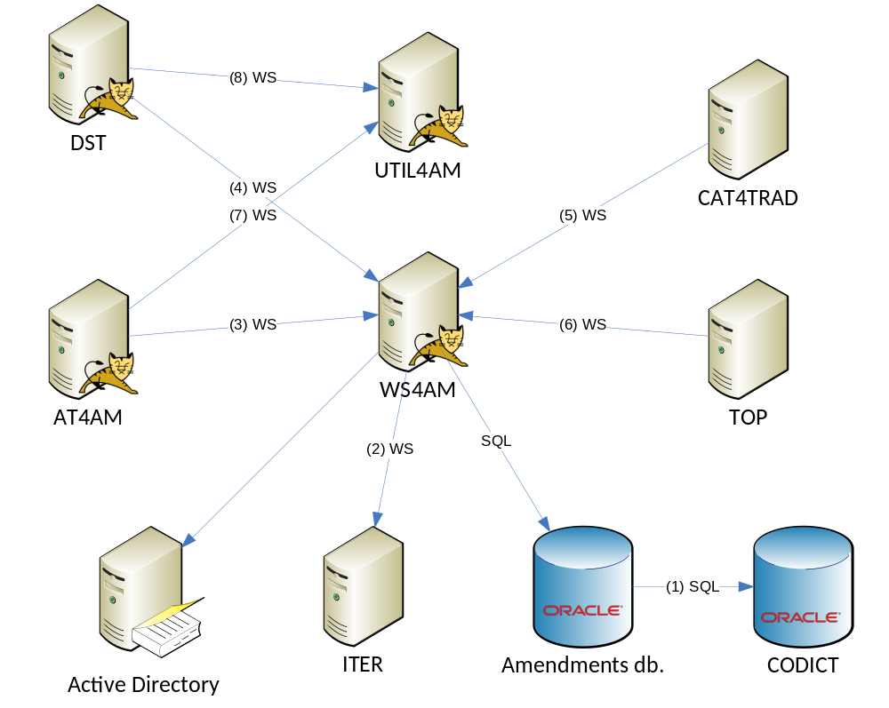

Type of data transferred:
- Persons, MEPs, MEP assistants, political groups, committees, languages
- Procedures, dossiers, documents
- All data displayed on web pages
- All data displayed on web pages
- Amendments and source texts in XML format
- In output, data related to a given Feuille de Route
- In output, result of comparison of given text strings (diff), and result of spell checking of given text string (spell checker)
- In output, result of comparison of given text strings (diff), and result of spell checking of given text string (spell checker)

Application integration criticality
Reference | Protocol | Synchronicity | Frequency | Business Criticality
1 | SQL | Synchronous | Every hour, one batch of 10 SQL commands | High
2 | Web services | Synchronous | Every night, one batch of about 500 calls  + sometimes, one set of about 5 calls on admin user request | High
3 | Web services | Synchronous | One call on each end user action, up to 40 per second | High
4 | Web services | Synchronous | One call on each end user action, up to 20 per second | High
5 | Web services | Synchronous | Up to 1000 calls per day | High
6 | Web services | Synchronous | Up to 10 calls per minute | High
7 | Web services | Synchronous | One call on each amendment creation/update, up to 20 per second | High
8 | Web services | Synchronous | One call on each amendment creation/update, up to 10 per second | High

System

List of required system services
Database | Oracle Database
File system (direct access, sharing, FTP, ...) | N
Directory (Active Directory, other) | Active Directory authentication
Mails (Sending mails from an application) | Log4J SMTP appender for notification of runtime errors
Other | N

System services schema (optional)
For clarity (and mostly if you have asked for multiple runtimes), please provide a schematic vision of the interaction between system services and applications.

Security
This chapter describes the needs for security (secure client access, integration, confidentiality (signature) data exchanged or stored, business services implemented, etc.).

Authentication mechanism
Security is handled by the application container with authentication being handled by the Active Directory.

Authorization mechanism
Authorization is handled by LDAP/CODICT with LDAP user groups.

Specific confidentiality needs

Specific Development Tools
The purpose is to mention only components which need a special or specific attention
The ICTAS Unit provides standard tools for the development of applications.
Mention here licence-limited tools you may need (restricted use product):
Oxygen XML | Y
Modelling tool UML | Y
Microsoft Project | Y
Microsoft Visio | Y
Non standard tools and justification:

Annex: Statistics on AT4AM usage

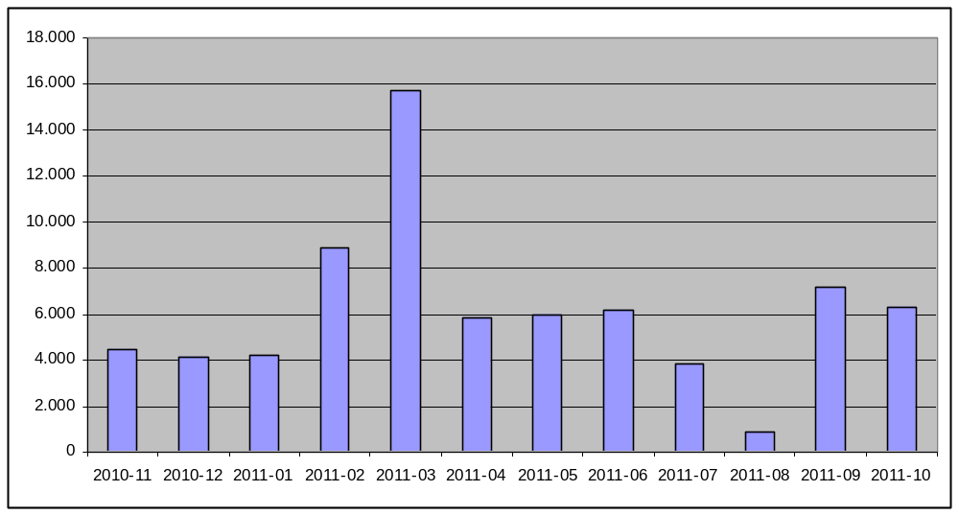
Amendments created by month

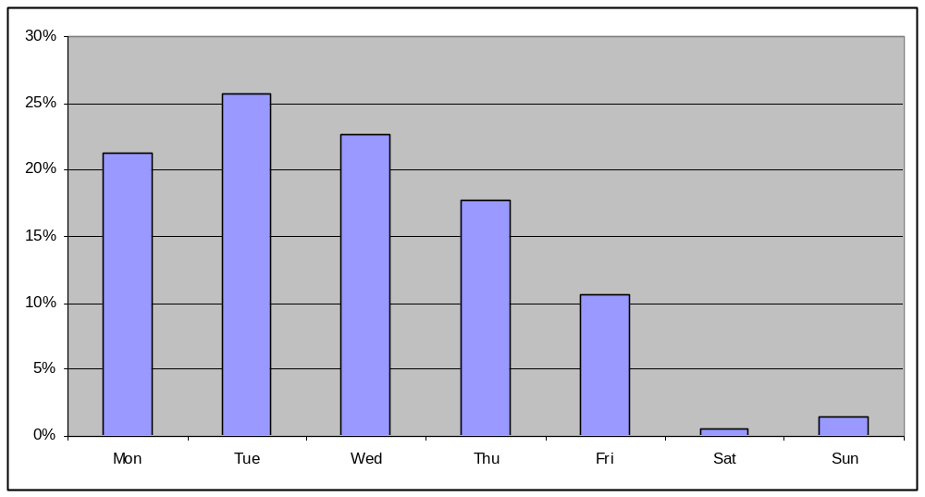
Amendments created by week day

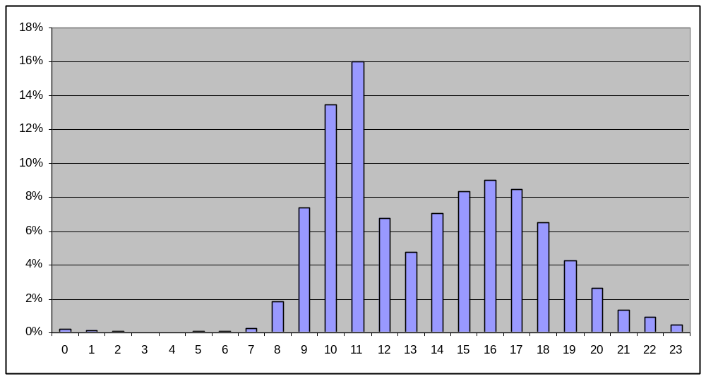
Amendments created by day hour

E: Examination, R: Responsible, I: Information, C: Contribution, A: Approval
Runtime: for example: Tomcat, HornetQ...etc
Environment (DEV, PPO, FOR, PROD, INT...etc)
An identifier helping to point this relation in the Application Integration Schema
Frequency of the interaction (e.g. once every night for a batch, thousands of calls per minute if directly related to end user input or interaction)

